填寫日期 | _103_年 12 月 21 日
所屬系所 | 保健營養生技系 | 指導老師 | 韓建國
社群名稱 | 保健學系可食性薄膜產品研發社群
本次心得主題 | Physical properties of edible emulsiﬁed ﬁlms based on carboxymethyl cellulose and oleic acid
本次主題類型  (請選一項) | □課程討論；■專題研究；□影片欣賞；□藝術表演；□參觀展覽；□其他：
一.學習過程： | CMC film is a very efficient oxygen, carbon dioxide, and lipid barrier. However, it has poor resistance to water vapor transmission.Nevertheless, its water vapor barrier properties might be improved by adding hydrophobic materials, such as lipids, into the film forming solutions.Oleic acid is liquid at room temperature hence, it is easily miscible with biopolymer without needing to further heating treatment.However, it has also been reported that incorporation of lipid materials into hydrophilic films may have unfavorable effects on the mechanical and optical properties of edible films. The major objectives of this study were to develop CMC/lipid composite films through emulsification and to determine the effect of the OA on the moisture barrier, mechanical, thermal and optical properties of the glycerol-plasticized films.
二.學習反思： | 油酸改善CMC膜的耐水性，甘油卻增加了它的水敏感性。在CMC上甘油的薄膜的機械性能的影響比油酸還大，在顏色值的主要差異是在b值的變化，甘油和油酸的含量導致了薄膜的B值變化。結合OA進入薄膜造成濁度增加。通過OA含量的增加，濁度加劇，b值也跟著增加。這種效應可以歸因於脂質乾燥而促進了薄膜的表面粗糙度相反的摻入甘油後的b值加越多則越接近控制組，但是甘油的​​濃度增加卻使L值減少。在一般情況下，可食性薄膜應盡可能接近無色盡可能地模擬常見的聚合物膜的外觀。因此，OA在膜基質摻入可能導致CMC膜的顏色改變產生負面影響。  除了油酸改善CMC膜的耐水性，但甘油卻增加了它的水敏感性
三.學習心得： | Addition of OA to the CMC films significantly improved the barrier property. However, the effect of OA on the mechanical properties was lower than glycerol. By increasing of OA content, the cloudiness of the CMC films was intensified and Hunter value (b) of the films increased.
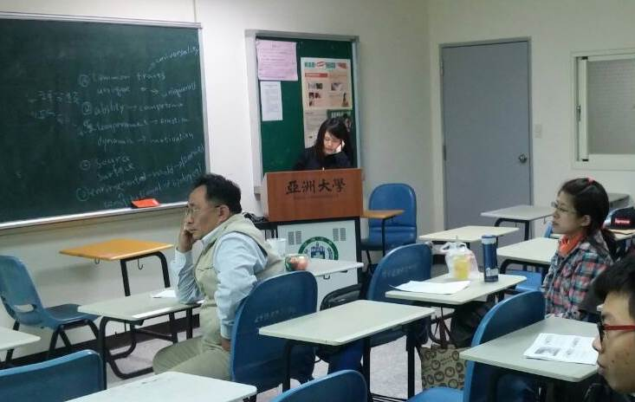
圖一、同學上台報告前人關於可食性薄膜產品研發和探討，並且講解說明。
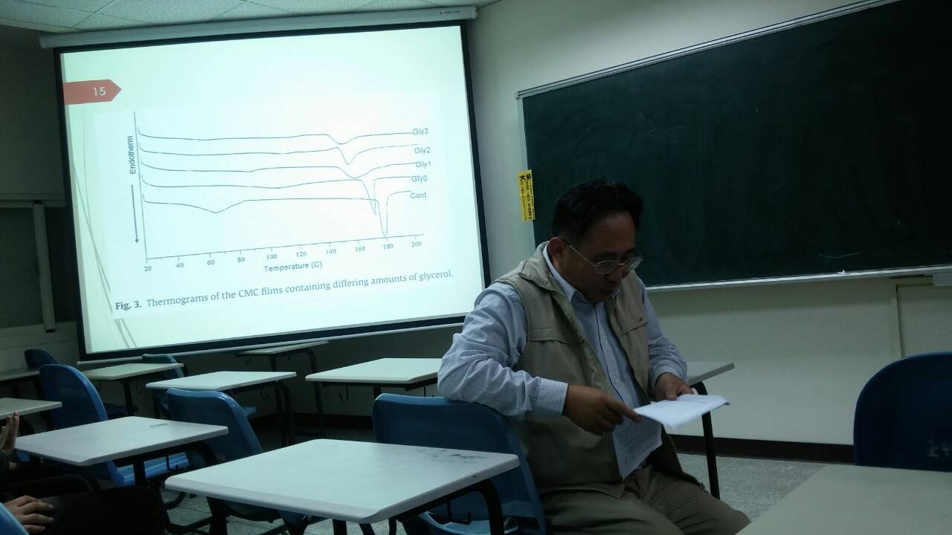
圖二、為了讓底下學生們踢得更清楚，老師正在為台上再次說明和補充，此外也將學生報告的錯誤矯正。

