填寫日期 | _103_年 12 月 21 日
所屬系所 | 保健營養生技系 | 指導老師 | 韓建國
社群名稱 | 保健學系菇類加工產品研發社群
本次心得主題 | Contributions of non-volatile and volatile compounds to the umami taste and overall flavour of shiitake mushroom extracts and their application as flavour enhancers in cooked minced meat
本次主題類型  (請選一項) | □課程討論；■專題研究；□影片欣賞；□藝術表演；□參觀展覽；□其他：
一.學習過程： | Shiitake mushrooms (Lentinus edodes) are traditional delicacies in Japan and other Far East countries when mushrooms are dried, the unique shiitake aroma is developed and the amounts of 50-guanosine monophosphate and vitamin D are higher than those in the fresh shiitake.  There are multiple receptors for the umami taste; some are glutamate specific, such as mGLUR1 and mGLUR4, whereas the heterodimer T1R1 + T1R3 responds to both amino acids and 50-ribonucleotides.  The overall flavour of shiitake is comprised of both non-volatile taste compounds and volatile aroma compounds Fresh shiitake has little odour, the main volatile compound being 1-octen-3-ol which is responsible for a sweet,earthy odour, typical of many mushroom varieties.
二.學習反思： | Drying the shiitake mushrooms results in increase of cyclic sulfur compounds, such as 1,2,4-trithiolane.  The cyclic 5-sulfur compound, lenthionine (1,2,3,5,6-pentathiepane) is a haracteristic volatile compound found in shiitake mushrooms, in both fresh and dried forms.  Soaking of dried shiitake in water can result in release of different profiles of volatile compounds, depending on factors such as the water temperature and pH.  A hot aqueous extraction of dried shiitake mushrooms could provide an extract with high levels of umami taste compounds that could be used as taste and flavour enhancers for meat products.
三.學習心得： | The levels of 5’-ribonucleotides, particularly GMP and AMP, were substantially higher in the high temperature extract  the levels of the volatile compounds remained greater at the 22 ℃ extraction  70 ℃ shiitake extracts could be used in order to enhance the umami  taste of food without significantly changing the flavour attributes  of the final product.
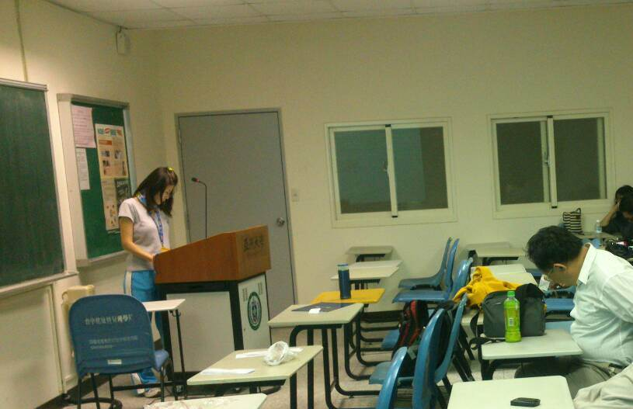
圖一、台上的同學正認真的將自己所看的期刊內容分享給其他組員。
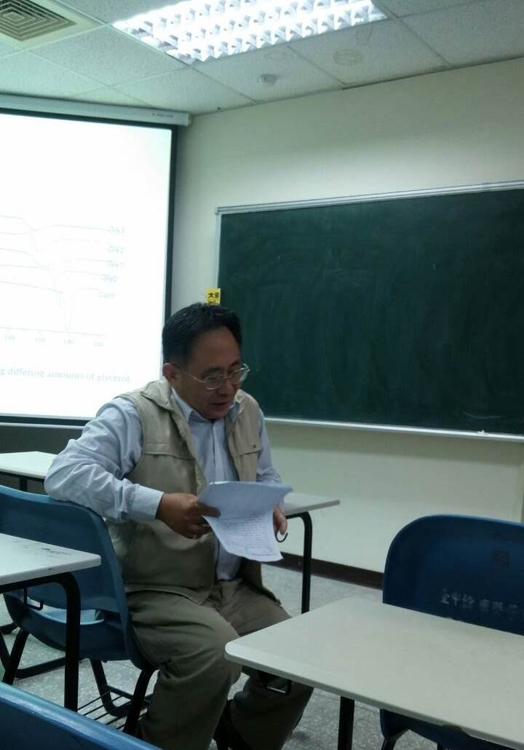
圖二、老師對剛剛報告時同學解釋不清楚的地方進行提問，和更正同學報告發生的錯誤並再次為台下學生講解一次。

