填寫日期 | _103_年 12 月 21 日
所屬系所 | 保健營養生技系 | 指導老師 | 韓建國
社群名稱 | 保健學系加工產品微生物分析社群
本次心得主題 | Evaluation of the wound healing potential of Wedelia trilobata (L.) leaves
本次主題類型  (請選一項) | □課程討論；■專題研究；□影片欣賞；□藝術表演；□參觀展覽；□其他：
一.學習過程： | This revival of interest in plant derived drugs is mainly due to the current widespread belief that “green medicine” is safe, and clinically effective, better tolerated by patients, less expensive and globally competitive .Repair of injured tissues occurs as a sequence of events, including inflammation, proliferation and migration of different cell types . Wounds provide an ideal environment for the growth of microorganisms .Have proposed in vitro and in vivo evidence to support the use of plant materials as topical anti-microbial agents to enhance wound healing . Wedelia trilobata have Kaurenoic acid has antibacterial, larvicidal and trypanocidal activity . Luteolin exerts antitumor, mutagenic and antioxidant effects, has both depressant and a stimulatory action .The aim of the present study was to investigate the wound healing potential of Wedelia trilobata leaves commonly employed by traditional healers. Parameters like antioxidant activity, antibacterial activity, and fibroblast activity were utilized to clarify its traditional use in a scientific investigation.
二.學習反思： | The wound healing response is aimed at renovating a tissue that is closely similar to the original one and involves several distinct but overlapping phases.  The ethyl acetate fraction displayed antibacterial and fibroblast stimulatory activities while the choloroform :methanol fraction exhibited antioxidant activity thereby suggesting potential wound healing properties.
三.學習心得： | The WEA fraction has further subjected to fractionation in an attempt to isolate the pure component responsible for the said activity. Found to be diterpene. Further studies to isolate the antibacterial, antioxidant and fibroblast stimulatory compounds that contributed to the wound healing properties of this plant are under process.
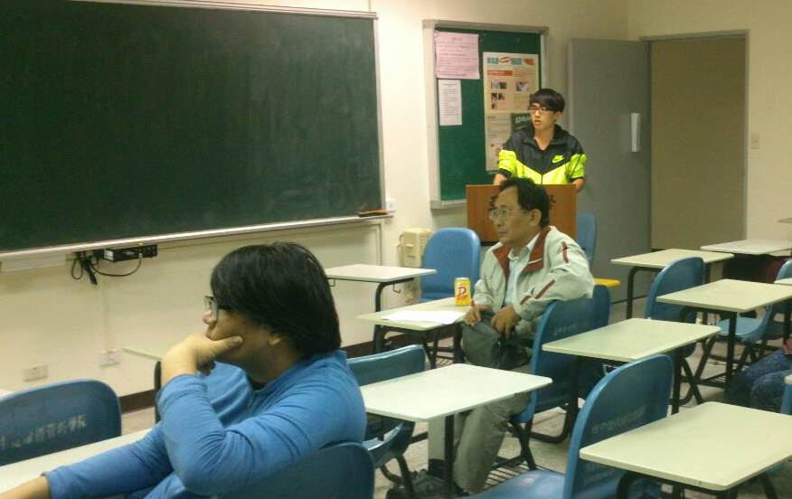
圖一、同學上台報告關於上網搜尋到的加工產品微生物的期刊，並且講解說明。
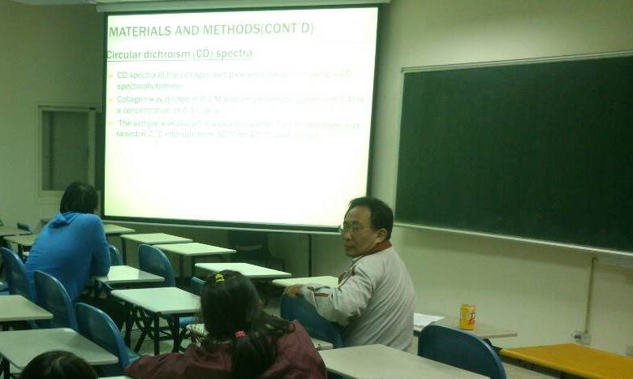
圖二、台下同組同學對報告不了解的內容提出疑問，並請老師講解說明。

